1. lswhoami 🡪 To get the username

1. hostname 🡪 To get the hostname

1. ls 🡪 to list the directories 
2. ls -la 🡪 List the directories including hidden and with other details Graphical user interface, text

   Description automatically generated
3. pwd 🡪 To see the directory you are currently working with

1. cd <directory name> : To enter the directory
2. cd .. 🡪 To go to the previous directory

1. cd 🡪 To go to home directory

1. cd <path> : open a particular directory using path 
2. touch <file name> 🡪 To create a file 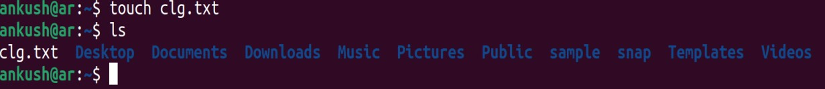
3. touch <file name>{from..to} 🡪 To create multiple files ending with from to to. Text

   Description automatically generated

1. vi / nano 🡪 Open the writing mode

vi

nano

1. vi / nano <file name> 🡪 create a file and open in writing mode

1. cat <file name> 🡪 To read the file

1. mkdir<directory name> 🡪 create a directory

1. mkdir -help 🡪 help in mkdir Text

   Description automatically generated
2. mkdir -v <directory name> 🡪 create a directory and give output for status Text

   Description automatically generated
3. mkdir -p <directory name/next directory> 🡪 Create a directory path Text

   Description automatically generated
4. rm <file name> 🡪 to delete a file

1. rmdir <directory name> 🡪delete directory

1. rmdir -p <directory name/next directory> 🡪 Delete a directory path Text

   Description automatically generated with medium confidence
2. mv <old file name> <new file name> 🡪 to renaming a file Text

   Description automatically generated
3. mv <file name> <path where to move> 🡪to move a file Text

   Description automatically generated